EE3011.ELECTRONICS 1

EXPERIMENT 2 LAB REPORT

Mehmet Akif Türkmenoğlu
150720061

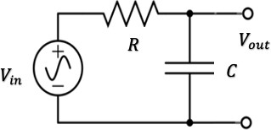
1.Circuit
Figure 1: RC low-pass filter.
1.1.Procedure
- Connect the circuit in figure 1. Use the circuit elements values given by the lab instructor. 𝑉_{𝑖𝑛} is a sinusoidal AC voltage source with frequency 𝑓 and maximum amplitude 𝑉_{𝑚𝑎𝑥}.

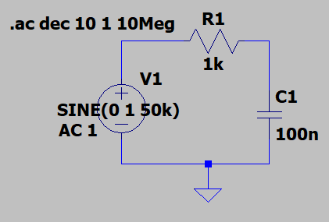
Figure 2. Circuit Drawn in LTSpice

- Simulate the circuit using the AC analysis function and generate the transfer function spectrum curve (versus frequency). Use dB scale for the transfer function magnitude and log scale for the frequency.

Note that;
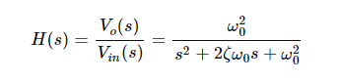
is the transfer function we are looking for.
- Change the value of 𝐶 and observe the simulation curves.

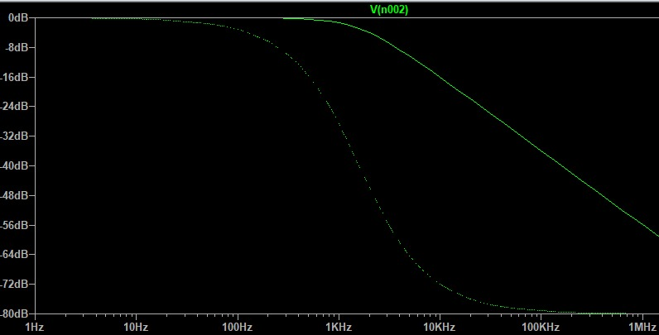
Figure 3. 100nF Capacitor AC Analysis

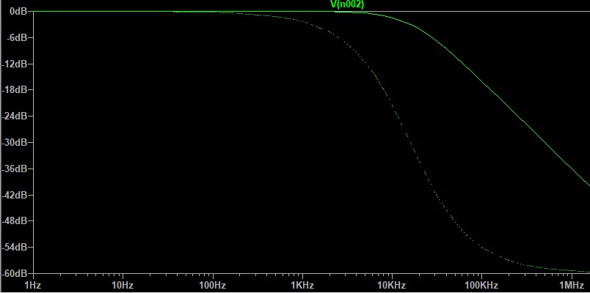
Figure 4. 10nF Capacitor AC Analysis
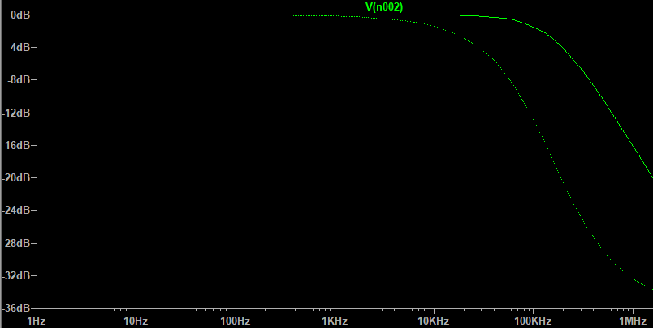
Figure 5. 1nF Capacitor AC Analysis

1.2.Results and Analysis
- From your simulations, find the simulated bandwidth of the filter for different values of 𝐶. Record your results in table 1.
Capacitor value | Simulated Bandwidth | Theoretical Bandwidth | % Difference
100nF | 1.59327 kHz | 1.58033 kHz | 0.81%
10nF | 15.9327 kHz | 15.8033 kHz | 0.81%
1nF | 159.327 kHz | 158.033 kHz | 0.81%

Table 1
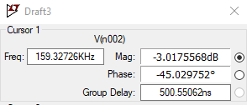
Figure 6. 1nF Capacitor -3dB Frequency

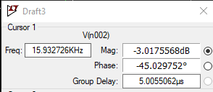
Figure 7. 10nF Capacitor -3dB Frequency

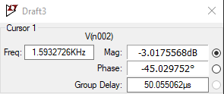
Figure 8. 100nF Capacitor -3dB Frequency

- Comment on the results in table 1.

Simulated and theoretical bandwidth are nearly the same. The difference is below %1. And I need to say that I couldn’t adjust the cursor that points the magnitude at the exact -3dB but it was -3.0175…

2.Circuit (Lab Assignment)
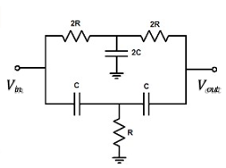
Figure 9. Circuit 3
- The lab instructor will assign one circuit to you with appropriate elements values.
- Connect the circuit using the circuit elements values given by the lab instructor. 𝑉_{𝑖𝑛} is a sinusoidal AC voltage source with frequency 𝑓 and maximum amplitude 𝑉_{𝑚𝑎𝑥}.

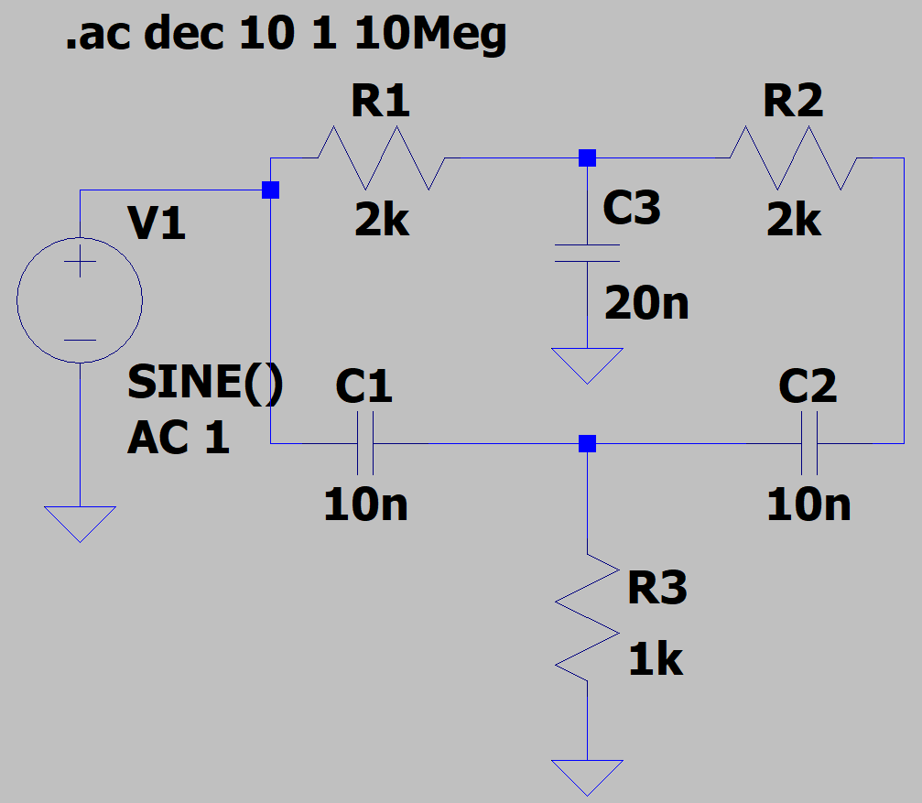
Figure 10. Circuit 3 Drawn in LTSpice (C=10nF)

The values of capacitors and resistors are specified according to given values which lab instructor said.

- Simulate the circuit using the AC analysis function and generate the transfer function spectrum curve (versus frequency). Use dB scale for the transfer function and log scale for the frequency.
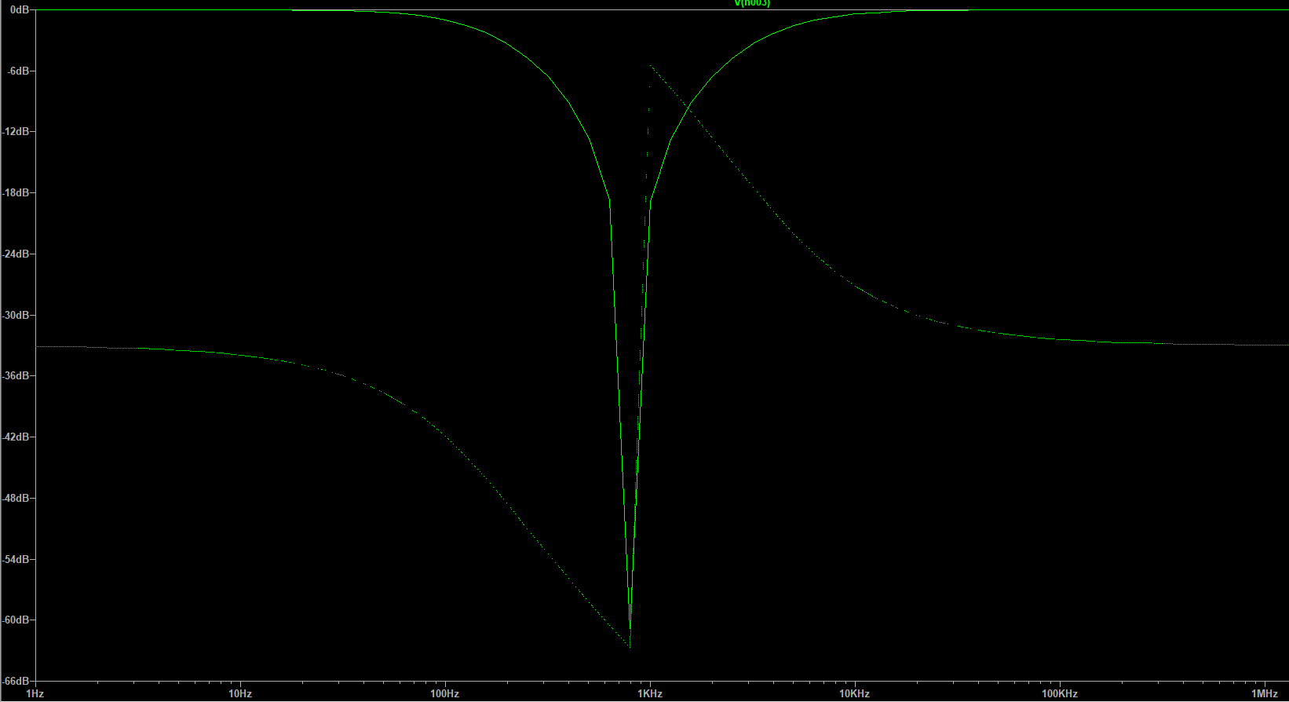
Figure 11. (db-Hz) Scale with C=100nF

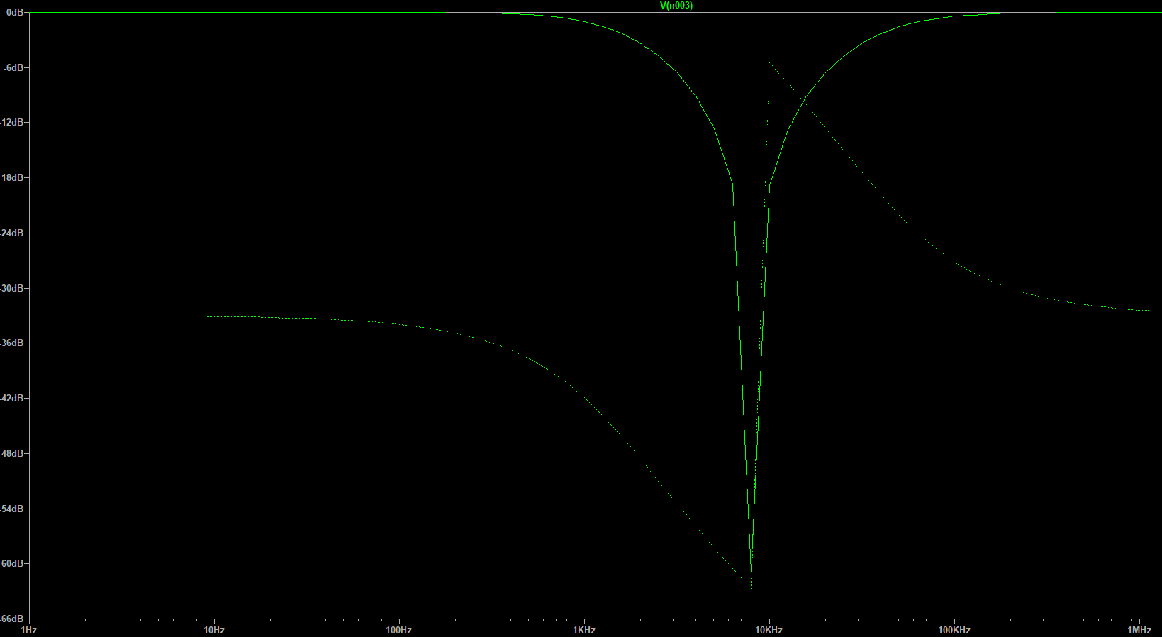
Figure 12. (db-Hz) Scale with C=10nF
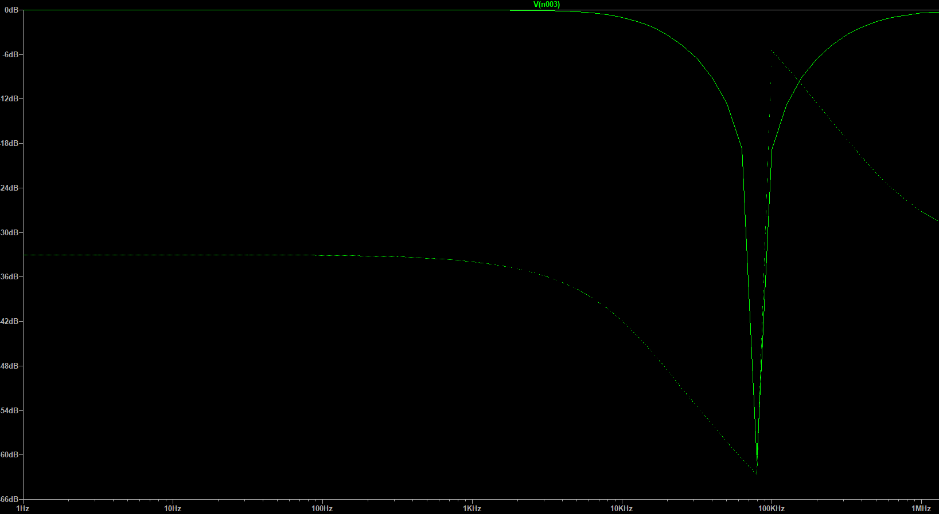
Figure 13. (db-Hz) Scale with C=1nF

- From your simulations, find the simulated bandwidth of this filter circuit.

To find bandwidth from simulation, I arranged the cursor that points the magnitude of dB to -3 Db and the frequency at that value is my bandwidth value. And it is 1.89345 kHz.

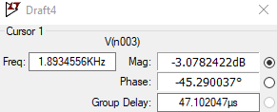
Figure 14. -3Db Frequency for Circuit 3

- Change the value of the circuit elements (one at a time) and observe the simulation curves. Write your conclusions regarding the effect of these elements on the circuit bandwidth. Can you come-up with a formula for the bandwidth in terms of 𝐶 and 𝑅?

I putted the transfer function spectrum-frequency curve for different values of capacitors in #3 as you will find above.

The formula for bandwidth is:
BW = f/Q where
f = 1/(2π√LC) resonant frequency
Q = R√C/L quality factor

- What kind of a filter is this circuit? Explain.

This filter blocks the frequencies within a certain range and gives easy passage to frequencies outside of that range. As we see above, low frequencies (left hand side) and high frequencies (right hand side) are displayed. It behaves the reverse of band-pass filter so I think that it is band stop filter.

